13. Test SSL configuration using testssl.sh
To perform a full test on the domain execute the following command. Then it will start the test and will take a little time to complete.
# ./testssl.sh www.google.com
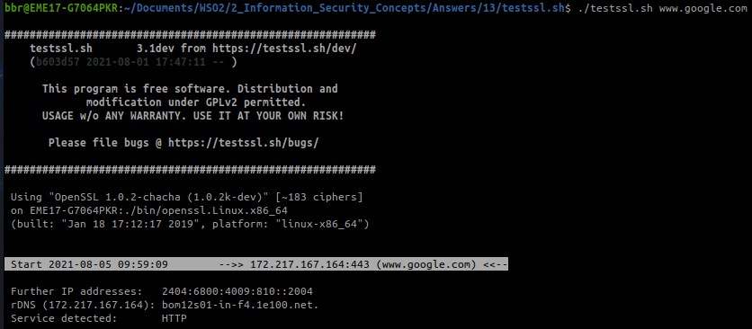
This test can be executed in single check options, single check as <options>
Testing protocols (-p) # ./testssl.sh -p www.google.com
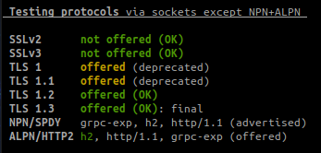

Testing cipher categories # ./testssl.sh -s www.google.com
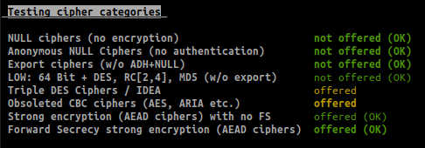

Testing server's cipher preferences # ./testssl.sh -P www.google.com
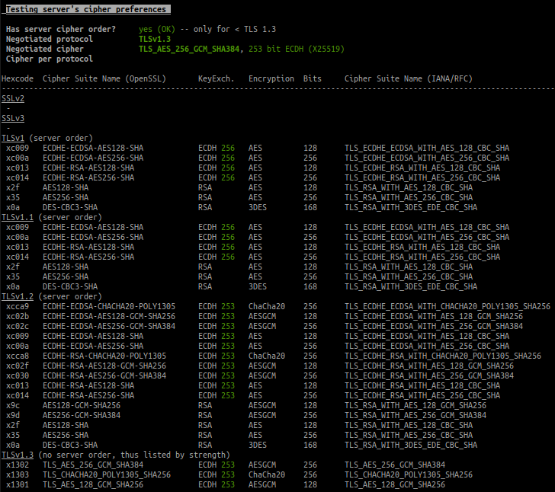
Testing vulnerabilities # ./testssl.sh -U www.google.com
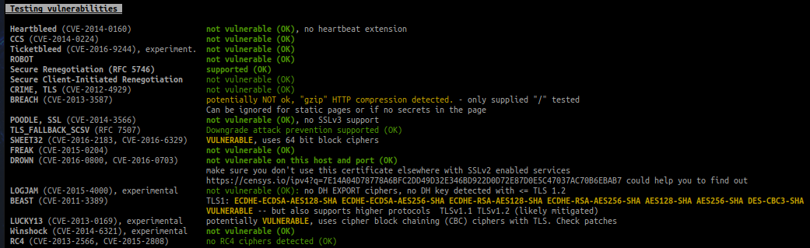
Testing server defaults (Server Hello)
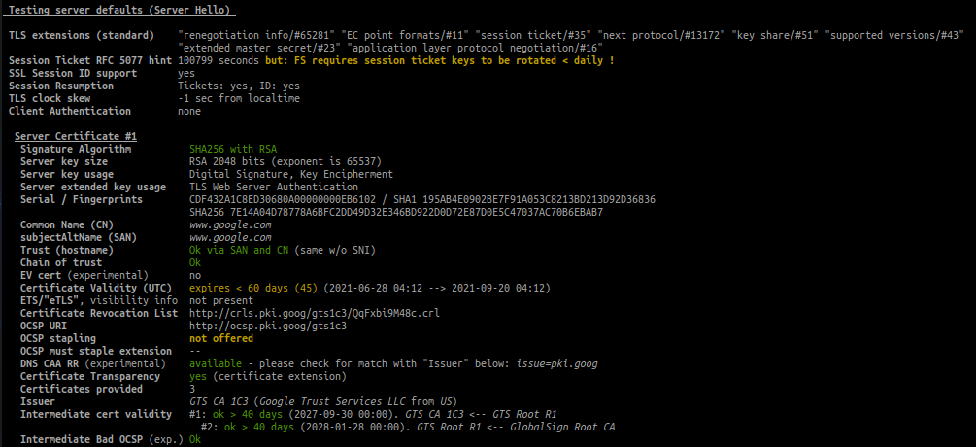
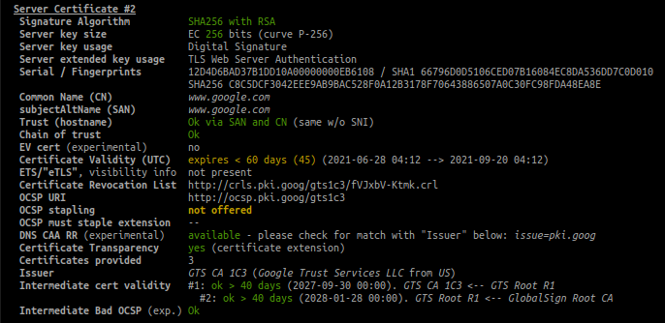

Tests HSTS, HPKP, server/app banner, security headers, cookie, reverse proxy, IPv4 address # ./testssl.sh -h www.google.com
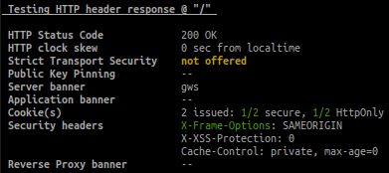

Test client simulations, see which client negotiates with cipher and protocol
# ./testssl.sh -c www.google.com
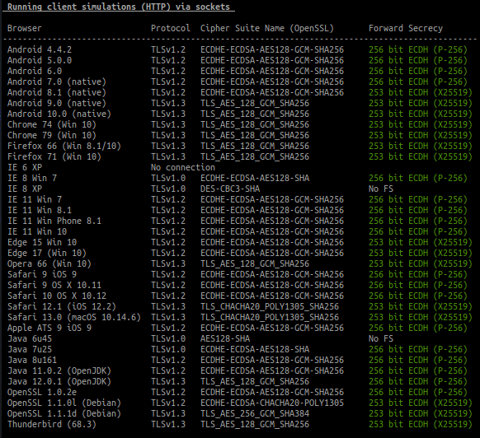
Rating (experimental)
